Question 3: Municipal Waste Collection Optimizer
3a) Data Types:

Write a Java program to store and display the following details of a waste collection vehicle:

Vehicle number – integer
Waste collected in kilograms – decimal value
Number of collection points – integer
Vehicle status – character
Use appropriate Java data types for each value and display all the details.

3b) If-Else Condition:

Write a Java program to check the waste collection status based on the amount of waste collected. Read the waste collected in kilograms.

If the waste collected is 100 kg or more, display "Collection Target Achieved".
Otherwise, display "More Waste Collection Required".
Use an if-else statement.

3c) Methods:

Write a Java program to calculate the total waste collected from two collection points using a method.

Create the following method:

calculateTotalWaste(double point1Waste, double point2Waste)
The method should return the total waste collected. Read the waste collected at the two collection points from the user, call the method, and display the total waste collected.

Answer:(penalty regime: 0, 0, ... %)
Ace editor not ready. Perhaps reload page?
Falling back to raw text area
ANSWER
3a) .
import java.util.Scanner;
public class WasteDemo1{
public static void main(String[]args){
Scanner sc = new Scanner(System.in);
System.out.println("Enter the amount of waste collected in KGs: ");
double waste=sc.nextDouble();
if(waste>=100){
System.out.println("Collection Target Achieved");}
else{
System.out.println("More Waste Collection is Required");}
}

}

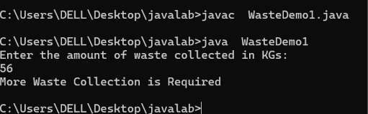

3b) .
import java.util.Scanner;
public class WasteDemo2{
public static void main(String[]args){
Scanner sc = new Scanner(System.in);
System.out.println("Enter vehicle number: ");
int vehicle = sc.nextInt();
System.out.println("Enter the amount of waste collected in KGs: ");
double waste=sc.nextDouble();
System.out.println("Enter the number of collection points: ");
int points = sc.nextInt();
System.out.println("Enter the status of Vehicle- Active(A) and Inactive(I): ");
String status =sc.next();
System.out.println("Vehicle Number: "+vehicle);
System.out.println("Waste collected: "+waste+" "+"Kgs");
System.out.println("No of Collection points: "+points);
System.out.println("Status of the vehicle: "+status);
}}

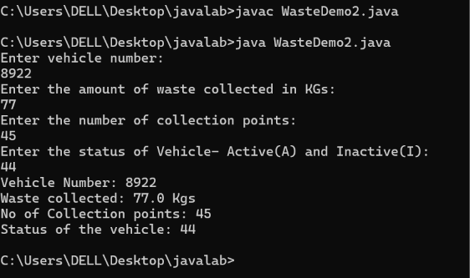
3c) .
import java.util.Scanner;
public class WasteDemo3{
public static double calculateTotalWaste(double point1Waste, double point2Waste) {
return point1Waste + point2Waste;}
public static void main(String[] args) {
Scanner sc = new Scanner(System.in);
System.out.println("Enter waste collected at Point 1: ");
double point1Waste = sc.nextDouble();
System.out.println("Enter waste collected at Point 2: ");
double point2Waste = sc.nextDouble();
double totalWaste = calculateTotalWaste(point1Waste, point2Waste);
System.out.println("Total waste collected: "+totalWaste);
}}

